**Numpy, Pandas and Visualization Questions**

1. Consider the dataset given below, and find out whether BMI and gender influence the Sales [Hint: Use group by and stack to create the bar plot] 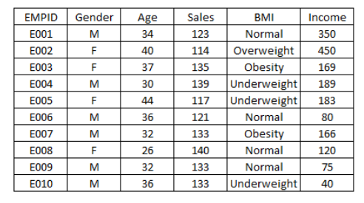
2. Create a dataset with Name column containing Title, First Name, Middle Name and Last Name. Separate out titles from the Name and create a separate column to store the titles.

[Hint : Use Split, lambda][Use: Titanic Dataset]

3. For above used Titanic Dataset, Create Pivot table for the following functionalities:

a. Use Sex as index parameter for the pivot table

b. Plot the table

c. Use Sex and Pclass as index parameter for the pivot table

d. Apply difference aggregation functions for the above pivot table.

e. Use Sex and Pclass as index parameter for pivot table and apply mean function on Survived

f. Use Sex and Embarked as index parameter for pivot table and apply mean function on Fare

g. Use Sex and Embarked as index parameter for pivot table and apply min,max,mean function on Fare

4. Refer above question and apply Stacking & Unstacking on the Pivot Tables.

5. Consider the Datasets given, perform following operations:

1. Given an excel sheet: America Data, read and load the sheets

2. Merge the datasets : north_america and south_america

3. Merge the datasets of the years 2011 to 2015

4. Plot the Average Labor hours per year for all the years from 2000 to 2015

5. Merge America and Asia Datasets and analyze.

6. Create a dataframe and perform following:

1. Create a Dataframe with Name, Subjects and Marks for the Students
2. Rank the dataframe by ascending and descending order
3. Rank the dataframe by dense rank if found 2 values are same
4. Rank the dataframe by Maximum rank if found 2 values are same
5. Rank the dataframe by Minimum rank if found 2 values are same
6. Rank the dataframe by group

8. Define a dictionary containing Name, Age, Qualification, Address, department, Designation for Employees. [ Create minimum 20 employee’s data] and Perform following:

a. Convert dictionary into Dataframe

b. Group Employees based on Qualification

c Group employees based on Department

d Group employees based on Designation.

e Sort employees based on Age

9. Perform Following on the arrays

a. Print an array of size M*N with its main diagonal elements as 1's and 0's everywhere else.

b. Print an array of size M*N in which all the elements are 1's.

c. Print an array of size M*N in which all the elements are 0's.

d. Given a space separated list of nine integers, convert this list into a 3*3 NumPy array.

e. Create a 5X2 integer array from a range between 100 to 200 such that the difference between each element is 10